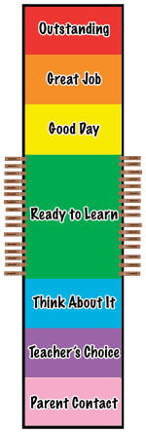

Clip Chart for Tracking Behavior

All of the Kindergarten through fifth grade classrooms are using this Clip Chart to track student behavior. It is a simple way to promote positive behavior in the students here at F.B.C.S.

In our classroom, each student begins each day with his/her clip (clothespin) on the green section labeled “Ready to Learn.” Each student’s behavior will determine if he/she clips up or clips down.

Students may clip up for following directions, staying on task, working cooperatively, working quietly, etc.

Students may clip down for not following directions, bothering others, interrupting me or their classmates when speaking, problems in the restroom, problems on the playground, etc.

The best part about this system is that students aren’t stuck on a level all day long. If they make a poor choice and have to clip down to “Think About It,” they have a chance to move back up to “Ready to Learn” without any consequences. They also can clip up to more than one level throughout the day when they continue to make good choices.

Please let me know if you have any questions regarding our Clip Chart.